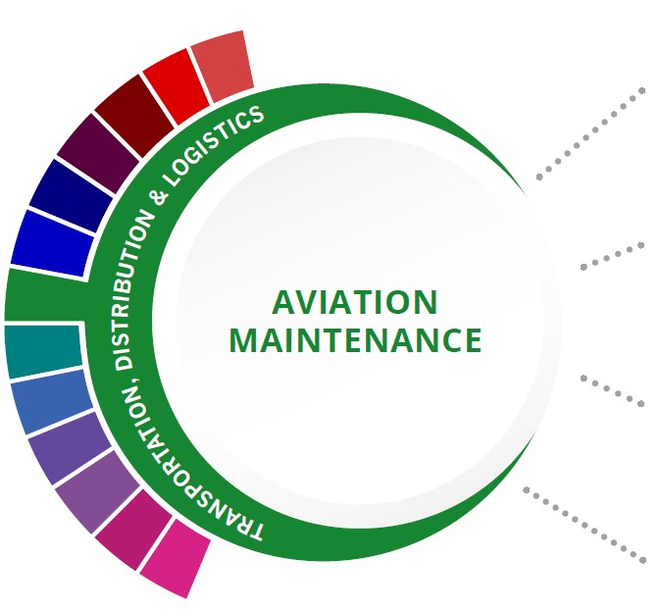
Statewide Program of Study: Aviation Maintenance; Transportation, Distribution, and Logistics Career Cluster
Level 1 | Introduction to Aircraft Technology
Level 2 | Occupational Safety and Environmental Technology I
Level 3 | Aircraft Airframe Technology/Lab
Level 4 | Practicum in Transportation Systems

HIGH SCHOOL/ INDUSTRY CERTIFICATION | CERTIFICATE/ LICENSE* | ASSOCIATE’S DEGREE | BACHELOR’S DEGREE | MASTER’S/ DOCTORAL PROFESSIONAL DEGREE
Aerospace Manufacturing Certification | Avionics Electronics Technician | Avionics Maintenance Technology/ Technician | Airframe Mechanics and Aircraft Maintenance Technology/ Technician
 | Aircraft Electronics Technician | Aircraft Powerplant Technology/ Technician
 | Aerospace/ Aircraft Assembly Maintenance Certification | Airframe Mechanics and Aircraft Maintenance Technology/ Technician
Additional industry-based certification information is available on the TEA CTE website. For more information on postsecondary options for this program of study, visit TXCTE.org.
Occupations | Median Wage | Annual Openings | % Growth
Aircraft Mechanics and Technicians | $58,698 | 1,469 | 9%
Avionics Technicians | $59,114 | 170 | 9%

WORK BASED LEARNING AND EXPANDED
LEARNING OPPORTUNITIES
Exploration Activities: | Work Based Learning  Activities:
Participate in SkillsUSA  Explore virtual aviation websites | Seek part-time work at an airport, aviation services agency, or airline

The Aviation Maintenance program of study introduces students to the occupations and education opportunities related to inspecting aircraft, maintenance procedures, air navigational aids, air traffic controls, and communications equipment to ensure conformance with federal safety regulations.
The Transportation, Distribution, and Logistics Career Cluster focuses on careers in planning, management, and movement of people, materials, and goods by road, pipeline, air, rail, and water. It also includes related professional support services such as transportation infrastructure planning and management, logistics services, mobile equipment and facility maintenance.

Successful completion of the Aviation Maintenance program of study will fulfill requirements of the Business and Industry Endorsement. Revised - March 2022

COURSE INFORMATION

COURSE  NAME | SERVICE ID | PREREQUISITES (PREQ)  COREQUISITES (CREQ) | Grade
Introduction to Aircraft Technology | 13039350 (1 credit) | None | 9-12
Aircraft Airframe Technology/Lab | 13039400 (2 credits) 13039410 (3 credits) | PREQ: Introduction to Aircraft Technology | 10-12
Aircraft Powerplant Technology/Lab | 13039500 (2 credits) 13039510 (3 credits) | PREQ: Introduction to Aircraft Technology | 11-12
Practicum in Transportation Systems | 13040450 (2 credits)  13040455 (3 credits)  13040460 (2 credits)  13040465 (3 credits) | None | 11-12

FOR ADDITIONAL INFORMATION ON THE TRANSPORTATION, DISTRIBUTION, AND LOGISTICS CAREER CLUSTER, PLEASE CONTACT: CTE@tea.texas.gov
https://tea.texas.gov/cte

(District) offers career and technical education programs in (types of programs offered). Admission to these programs is based on (admission standards). It is the policy of (District) not to discriminate on the basis of race, color, national origin, sex or handicap in its vocational programs, services or activities as required by Title VI of the Civil Rights Act of 1964, as amended; Title IX of the Education Amendments of 1972; and Section 504 of the Rehabilitation Act of 1973, as amended. It is the policy of (District) not to discriminate on the basis of race, color, national origin, sex, handicap, or age in its employment practices as required by Title VI of the Civil Rights Act of 1964, as amended; Title IX of the Education Amendments of 1972; the Age Discrimination Act of 1975, as amended; and Section 504 of the Rehabilitation Act of 1973, as amended. (District) will take steps to assure that lack of English language skills will not be a barrier to admission and participation in all educational and vocational programs. For information about your rights or grievance procedures, contact the Title IX Coordinator at (physical address of Coordinator) (email address of Title IX Coordinator), (phone number of Title IX Coordinator), and the Section 504 Coordinator at (physical address of Coordinator), (email address of Section 504 Coordinator), (phone number of Section 504 Coordinator)

